Create a simple cloud software application for Property Buying &amp; Rental process (In Chennai city) using any Cloud Service Provider to demonstrate SaaS.

Aim :

To design and develop a cloud-based Property Buying and Rental application for Chennai city using Zoho Creator, in order to demonstrate the Software as a Service (SaaS) model.

Procedure :

- Logged in to Zoho Creator using a Zoho account.
- Created a new blank application named Property Buying & Rental System – Chennai.
- Designed a form to collect property, owner, and transaction details.
- Added required fields such as property type, location, area, price, and availability status.
- Configured dropdown fields with Chennai locations and property options.
- Created workflows to automatically set property availability.
- Generated reports to display available, rental, and sale properties.
- Deployed the application on Zoho Cloud and accessed it through a web browser.
- Tested the application by adding sample property records.

Output :

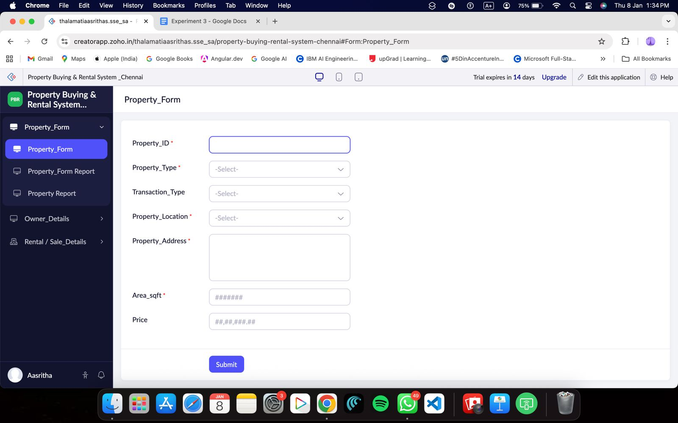
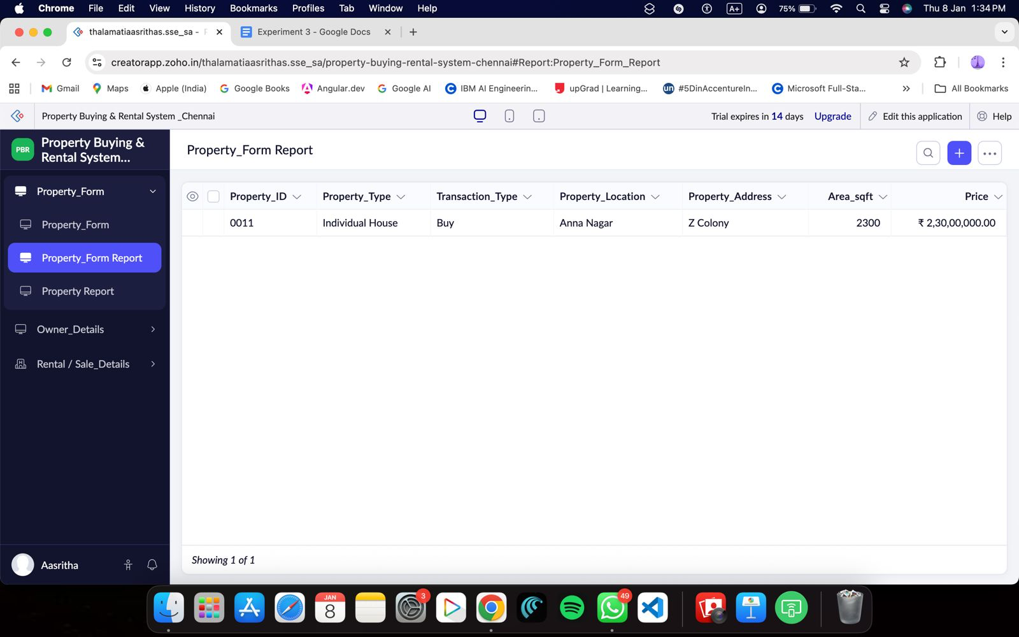

OWNER DETAILS :
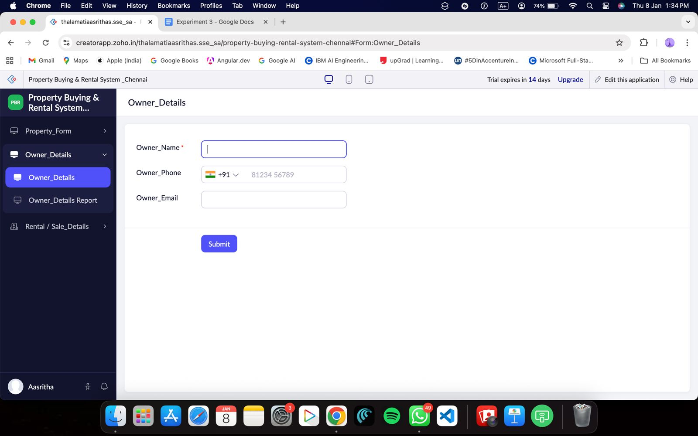

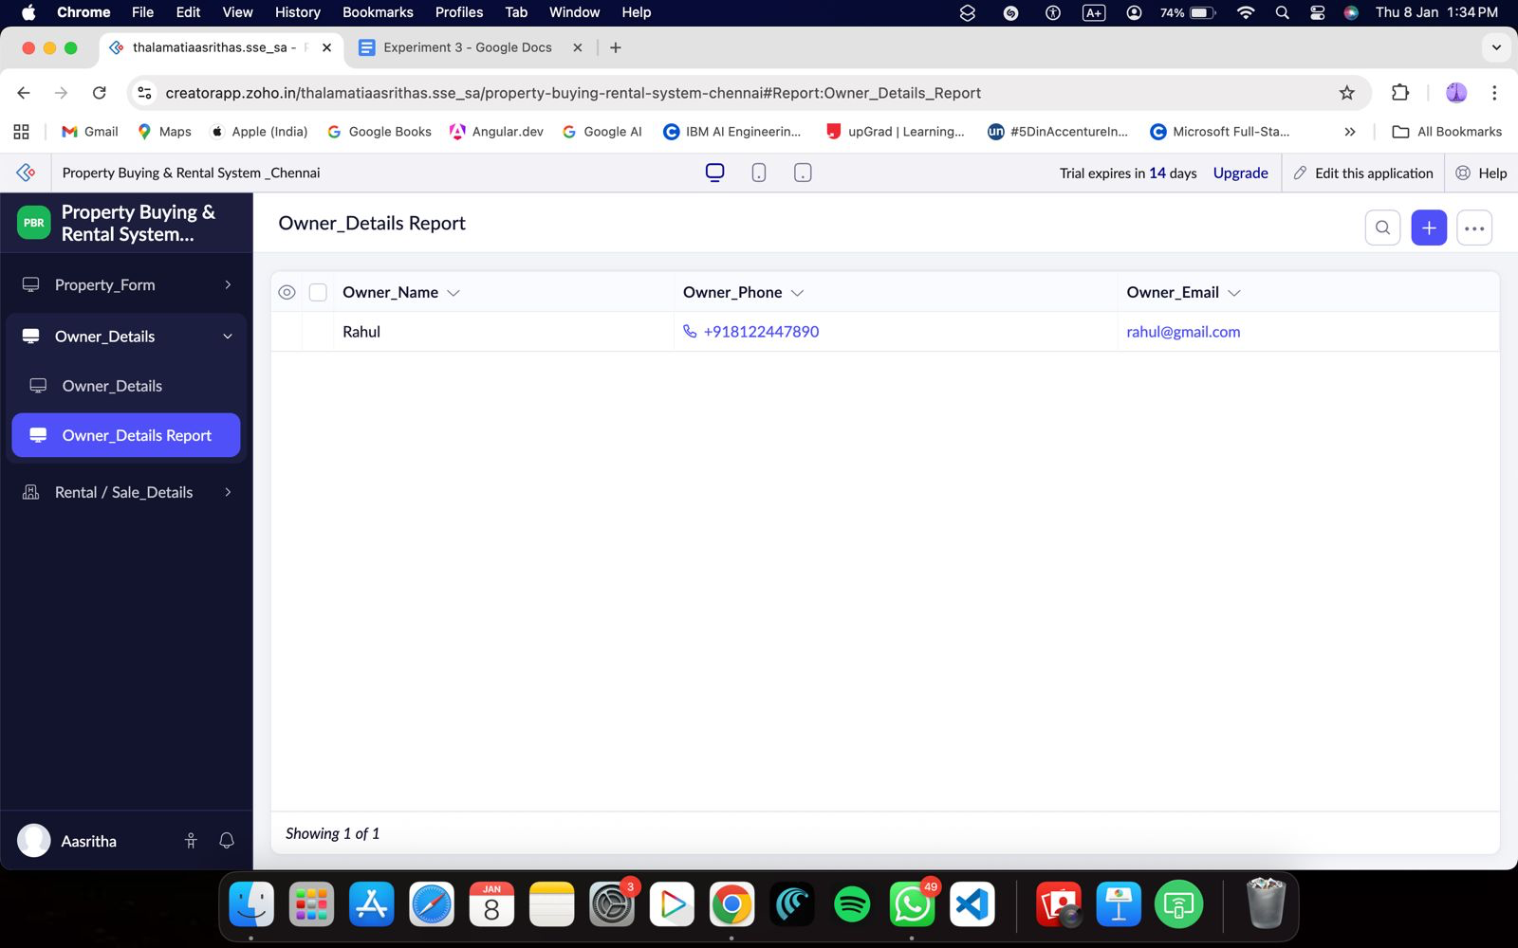
Rental/Sale_details :

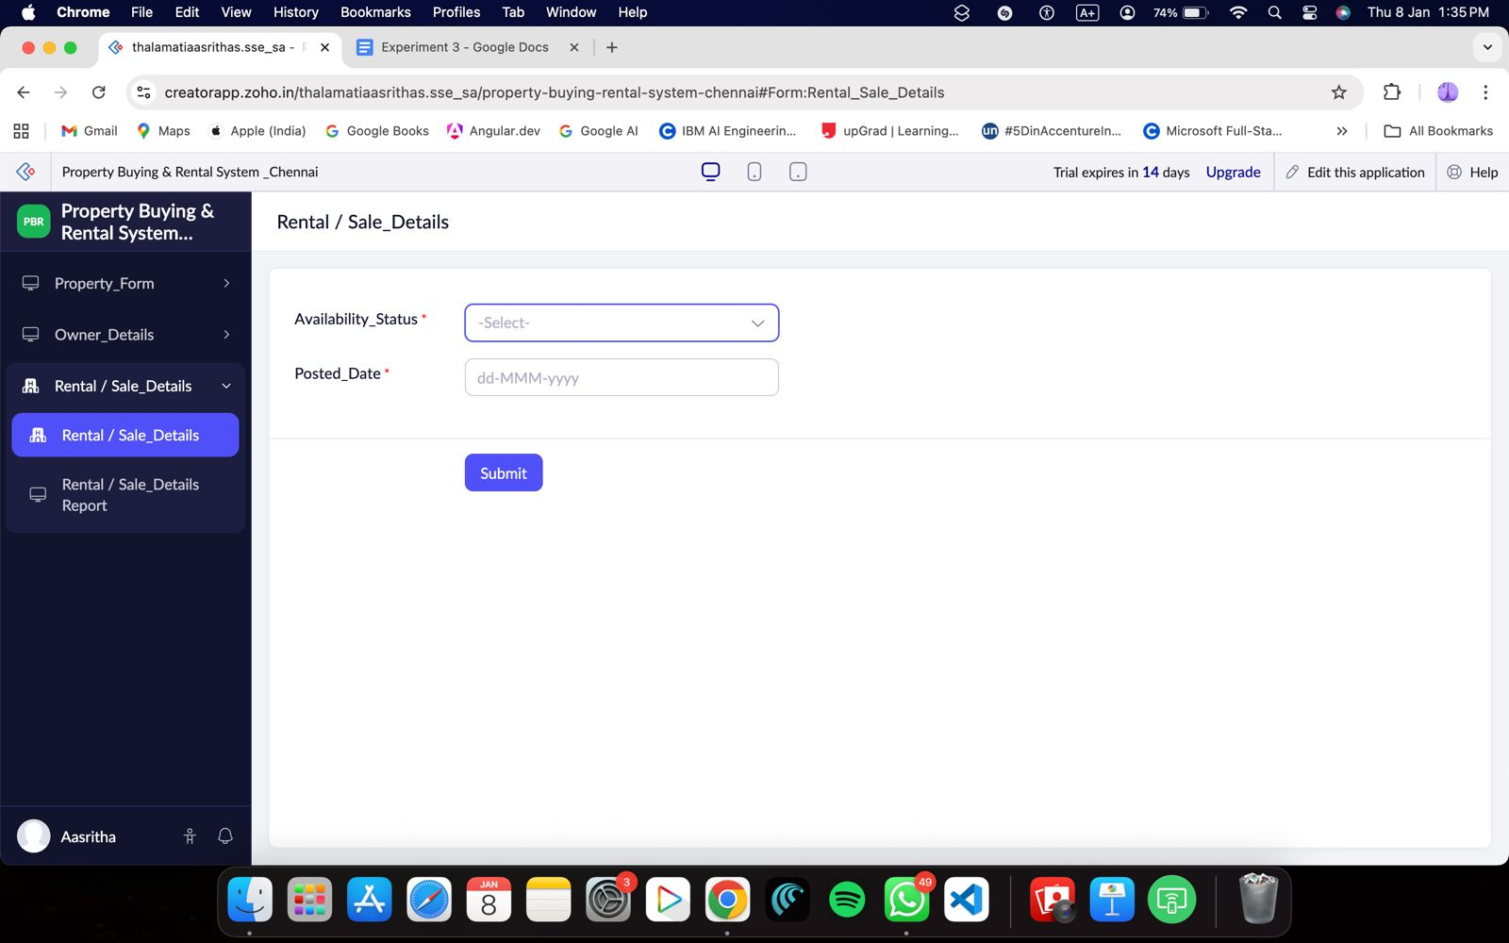

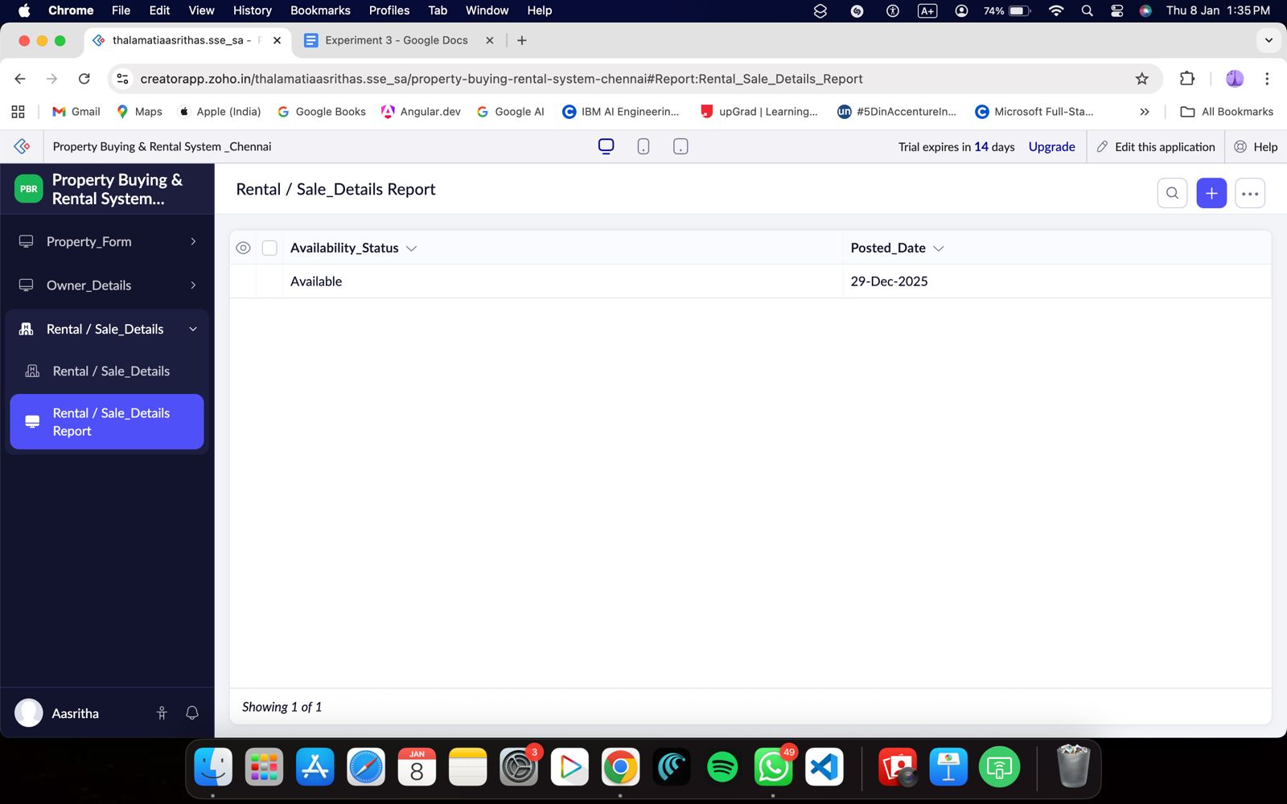

Result :

A cloud-based Property Buying and Rental System for Chennai city was successfully developed and deployed using Zoho Creator. The application enables users to add, view, and manage property details online without local installation, thereby successfully demonstrating the Software as a Service (SaaS) model.

